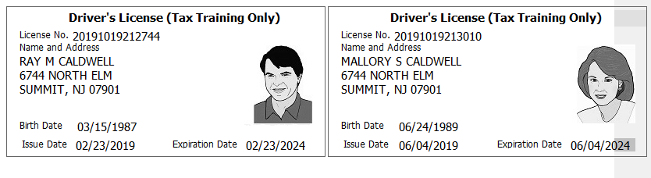
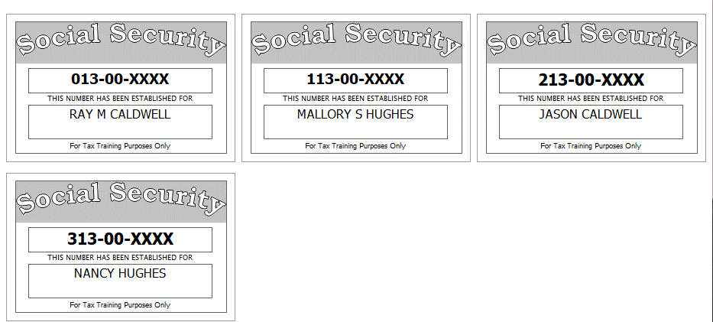

Other Information:
- The Caldwells paid $2,100 a month for rent
- The Caldwells wish to have their refund or balance due treated the same way for Federal and NJ.
- The Caldwells do not wish to contribute to either the presidential or gubernatorial election funds
- Last year, the Caldwells had a balance of $5 due on her NJ return which they paid.
- The Caldwell purchased a TV in Delaware where there is no sales tax and brought it back to NJ. The cost was $500.

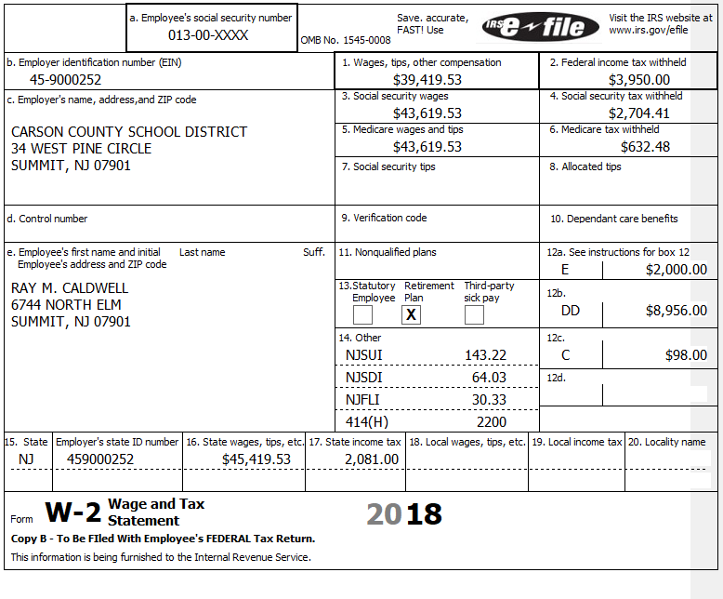
Supplemental information that accompanied this W-2 shows the following payroll deductions-
$1500 for Sec125 health insurance payments
$ 300 for Sec125 life insurance premiums

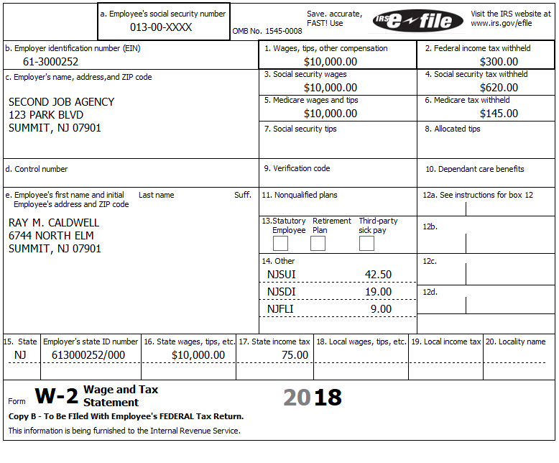
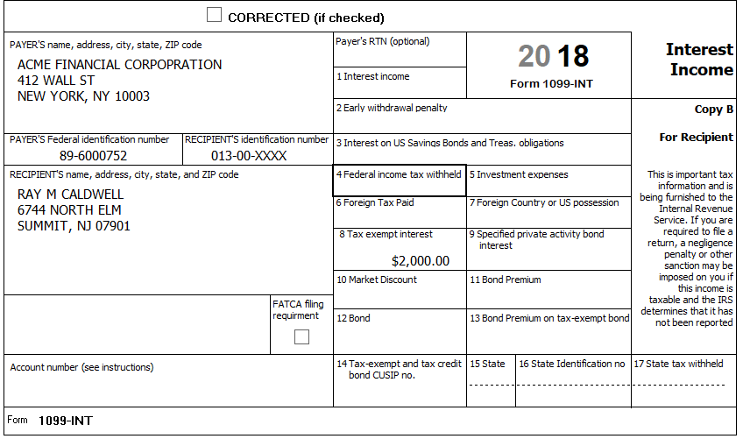
The supplemental information provided states that the tax-exempt interest came from the following sources:
New Jersey Turnpike Bond $200
California Freeway Bonds $800
Arizona Build The Wall Bonds $1,000

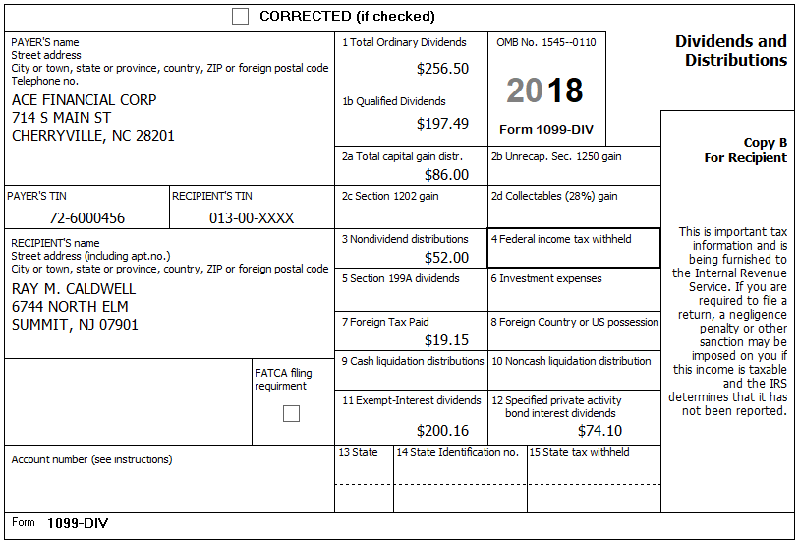

The exempt interest dividends on line 11 of the 1099-DIV is:
- $50.16 from Dreyfuss NJ Tax-Exempt Fund
- $150 from Fidelity Municipal Tax-Exempt Fund
- The following table was provided by Ray which he obtained from ACE Financial Corp.

 | Dreyfus New Jersey Tax-Exempt Fund | Fidelity Municipal Tax-Exempt Fund
Puerto Rico Recovery Bonds | 5% | 9%
Federal Treasury Bonds | 4% | 1%
New York Thruway Bonds | 8% | 40%
New Jersey Turnpike Bonds | 81% | 45%
Misc | 2% | 5%

:
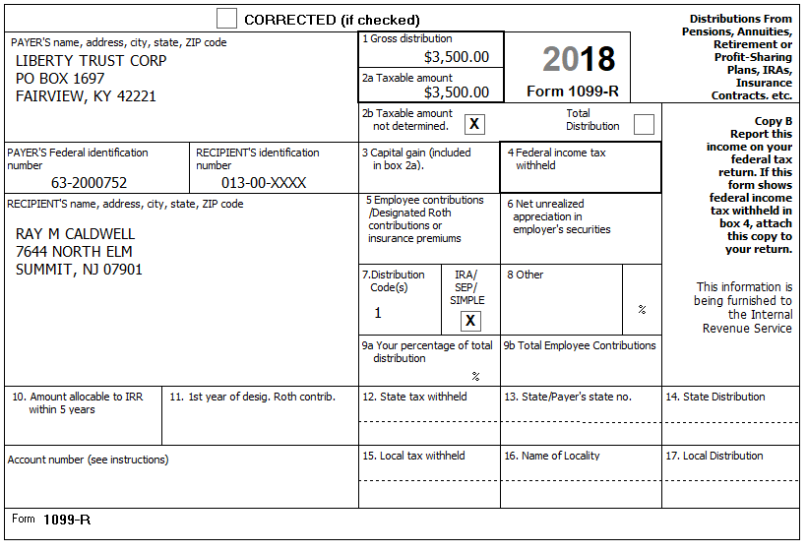

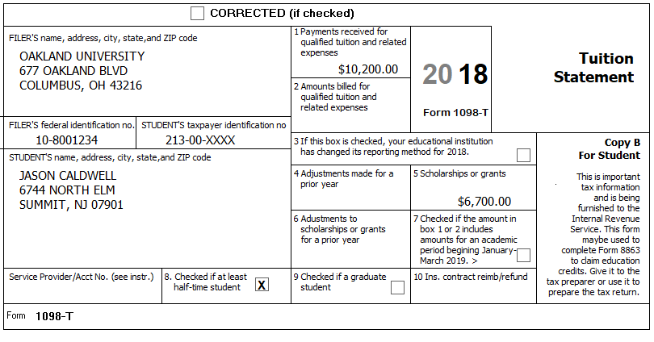
Interview Notes: Ray provided the following details about these college expenses-
Tuition and Fees $10200 (as per Box 1 of the 1098-T)
Room and Board $3300
Athletic Fee (voluntary) $100
Books Purchased Online $275

Interview Notes:
Mallory supplements the family income as a costumed story teller. She visits a local daycare center twice a month and performs at children’s parties. She maintains meticulous income and expense records.

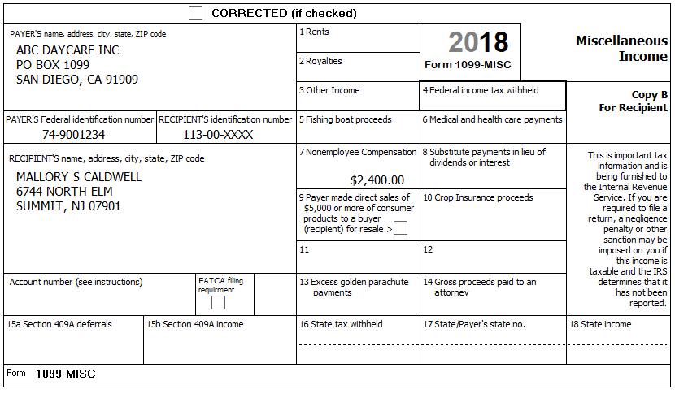
Mallory Caldwell –Summary of income and expenses:
Income: ABC Daycare: $2,400.00
Children’s parties (paid in cash): $5,500.00
Expenses: License/Fees: $190.00
Liability Insurance: $315.00
Costumes: $1,389.97
Candy/prizes: $278.46
Books: $261.17
Advertising: $200.00
Mileage: Commuting – 1,367, Business – 340, Other – 10,562
Her car is a 2010 Toyota was placed in service 3/23/2014. She did have a second car available to her and the Toyota was available for personal use. She has a written record of all her mileage.
Mallory made a federal estimated tax payment of $700.00 on June 11.
She also paid $100 estimated tax to New Jersey on June 11.

